**Requirements Specifications**

**P02:Baichday**

**<team member names & ids>**

|  |  |
| --- | --- |
| **Student ID** | **Name** |
| **23100157** | **Moiz Nafey** |
| **23100334** | **Silal Anwar** |
| **23100089** | **Mahad Mubashir Beg** |
| **23100181** | **Nashit Iftikhar** |
| **23100225** | **Muhammad Arslan Ullah Tarar** |

|  |  |  |
| --- | --- | --- |
| **Content** | **Totals** | **Obtained** |
| Introduction & system actors | 5 | 5 |
| Use case diagram | 10 | 7 |
| Use case descriptions | 20 | 20 |
| Class diagram | 20 | 10 |
| Sequence diagram | 20 | 10 |
| State diagram | 5 | 5 |
| Non-functional requirements | 5 | 5 |
| Who did what | 5 | 5 |
| Review checklist | 5 | 5 |
| Overall formatting/template | 5 | 5 |
| Late submission penalty | -20 |  |
| **Total** | **100** | **77** |
| Review | 20 |  |
| **Grand Total** |  |  |

**Table of Contents**

1. Introduction 3

2. System Actors 4

3. Use Cases 5

3.1 Use Case Diagrams 5

3.2 Description of Use Cases 5

3.2.1 Withdraw cash 5

3.2.2 Transfer funds 6

4. Class Diagram 7

4.1 Diagram 7

4.2 Description 7

5. Sequence Diagrams 8

5.1 Use case Name e.g., Withdraw cash 8

5.2 Use case Name e.g., Transfer funds 8

6. State Diagrams 9

6.1 Diagram details 9

6.2 Diagram 9

7. Non-functional Requirements / Quality Attributes 10

8. Who Did What? 11

9. Review checklist 11

# Introduction

Pakistan is a huge country with a population numbering in the millions, yet the GDP of Pakistan remains rather low as compared to its massive population. We aim to facilitate the people of Pakistan by presenting our auction system. Our software will allow people to auction off their belongings to interested parties. Currently there exists no such platform that supports auctioning as a mechanism. In the status quo, people must spend valuable time and effort searching for customers to purchase their goods at a decent price. We aim to bridge this divide and bring value to the economy of Pakistan by solving this problem.

This software will target both businesses and individuals in the Pakistani context. Small scale businesses currently do not have a platform to bid for resources, and shipments. A small scale mobile phone retailer finds it very inconvenient to currently bid for a shipment of mobile phones and similarly, repair shops face the same issue with car spare parts. Our auction system will allow wholesalers to enter their products for retail vendors to bid on. This has the potential to facilitate both wholesalers and the retail industry of Pakistan. Likewise, on a more individual scale, people with valuable assets are unable to put up their goods for the best price and must sell at the highest customer they manage to find. Our model will allow these users to list their belongings and allow bidding on it for the user to find the best price they can get from their belongings.

Our software will function similar to an ecommerce marketplace but with the added functionalities of timed biddings, scheduling of bids and other functionalities that will make the auction system a good and worthwhile experience for the users we target.

# System Actors

|  |  |
| --- | --- |
| **Actor Name** | **Description** |
| Admin | Admin is the auction marketplace owner, a middleman entity ensuring smooth auction process and verification of products. Admin will provide customer support and track the progress of profits, bids and transactions. |
| Seller | The seller will be able to upload products on this platform and wait for people to bid on them. |
| Bidder | The bidder will be able to search for products that are auctioned and bid on them. |

# Use Cases

## Use Case Diagrams

[It is hard to read the diagram. I suggest you to split it in multiple diagrams. If some use cases are common to multiple users, they can be highlighted separately. ]

Common Use Cases for all users:

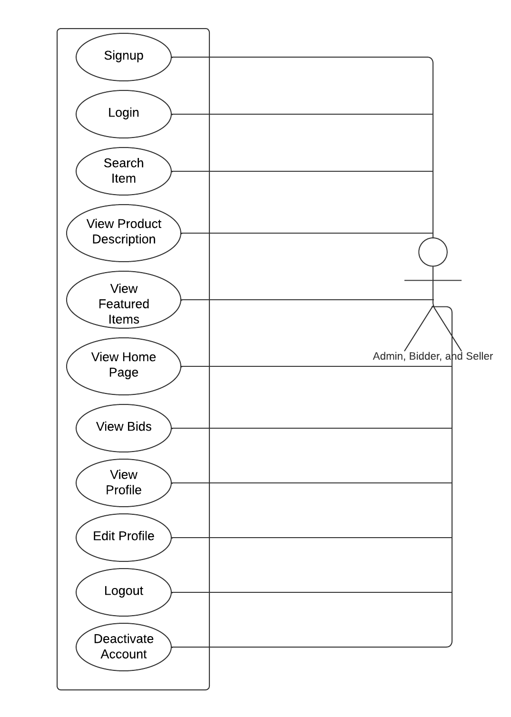

Common Use Cases for bidder and seller:

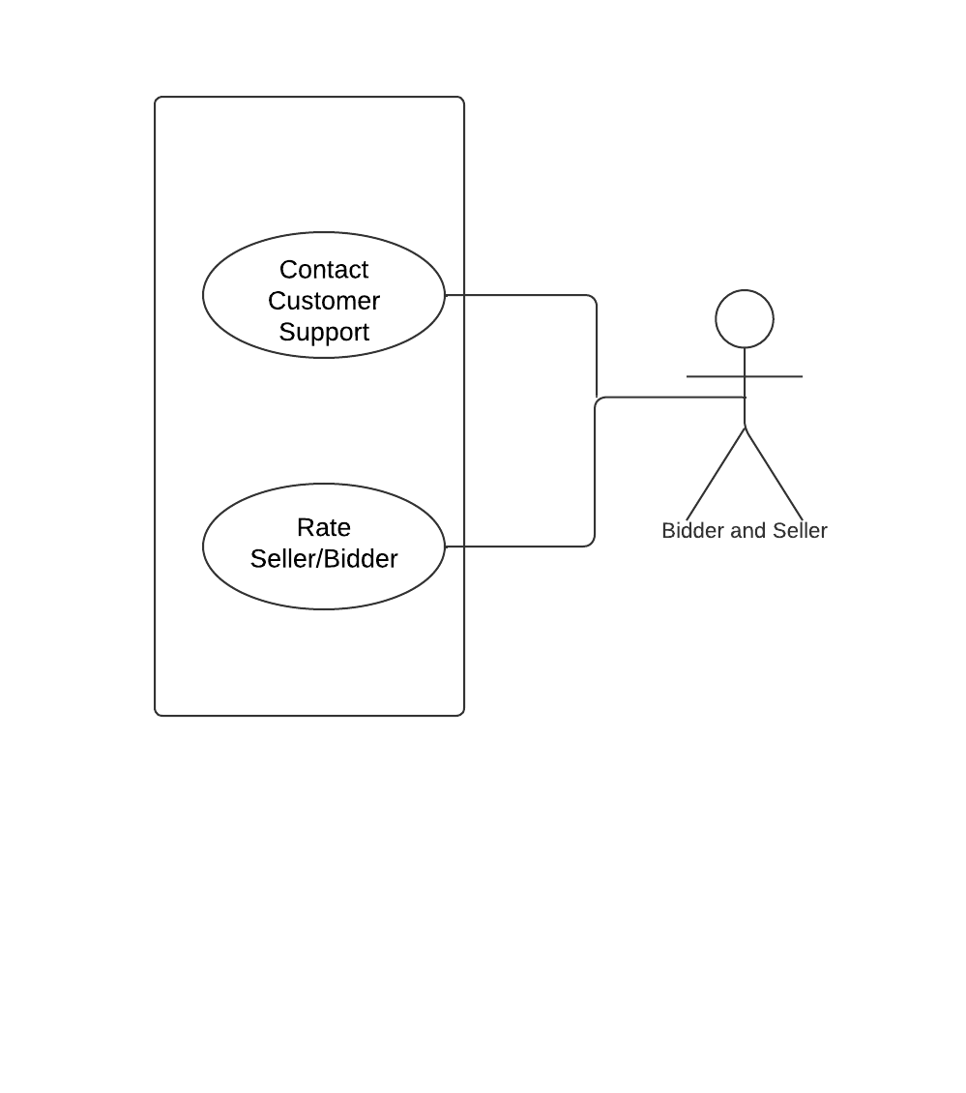

Individual Use Cases for users:

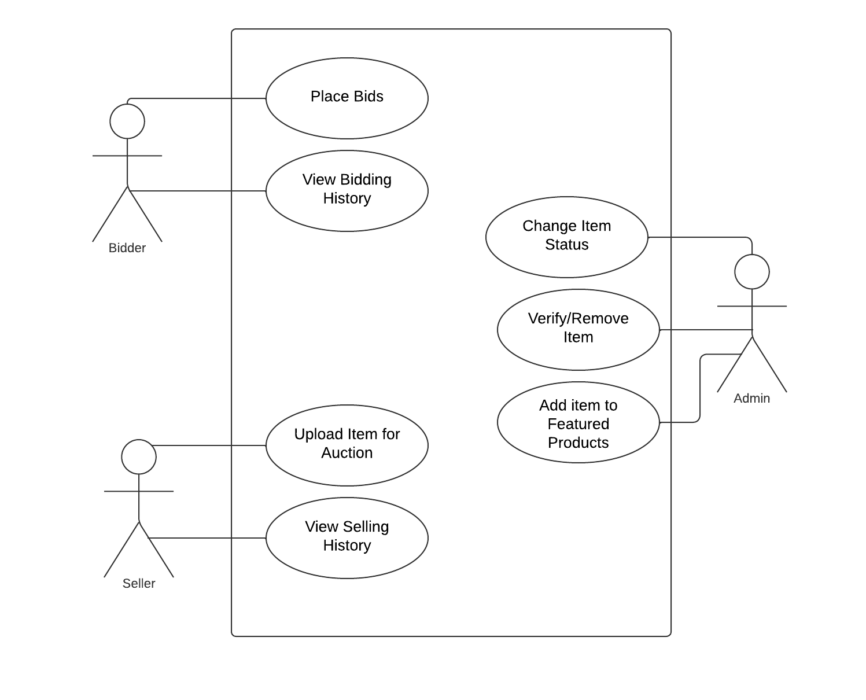

## Description of Use Cases

### Sign Up on the platform

|  |  |
| --- | --- |
| **Identifier** | UC-001 |
| **Purpose** | Allows the bidder/customer to sign up on the platform |
| **Pre-conditions** | User had a valid email address and phone number |
| **Post-conditions** | User account is created on the platform |
|  |  |
|  | |
| **Step #** | **Typical Course of Action** |  |
|  | The bidder/seller visits the website and selects the option to sign up on the platform. |  |
|  | The bidder/seller is prompted to enter his name, age, location, email and phone number |  |
|  | The bidder/seller confirms to sign up. |  |
|  | If the email and phone number are valid and have not been already used to sign up, they are sent a verification code on their email and phone number |  |
| **5.** | The bidder/seller is prompted to enter the verification code they received on their phone number and email address to complete the signup |  |
|  | If the verification code is correct, the bidder/seller will be directed to create a password for their account. |  |
|  | Once they set a password, they are directed to the login page. |  |
| **8.** | The use case ends. |  |
|  |  |  |
|  |  |  |
| **Step #** | **Alternate Courses of Action** |  |
|  | None |  |
| **Step #** | **Exception Paths** |  |
|  | In step 4, if the email or phone number are not valid or are already in use, an error message is displayed, and they are prompted to re-enter a valid email address/phone number |  |
|  | In step 5, if the bidder/seller enters an incorrect verification code, an error message is displayed, and they are prompted to enter the correct verification code again |  |

### Login on the platform

|  |  |  |  |
| --- | --- | --- | --- |
| **Identifier** | | UC-002 | |
| **Purpose** | | Allows the customer to login onto our platform | |
| **Pre-conditions** | | The *signup* use case has been successfully completed | |
| **Post-conditions** | | The user can have access to the features available on our platform | |
|  | | | |
| **Step #** | **Typical Course of Action** | |
|  | The bidder/seller opens the sign in page. | |
|  | The bidder/seller is prompted to enter their email and password | |
|  | If the email and password is correct, they are allowed access to the platform and use its features | |
|  | The use case ends | |
|  | | | |
| **Step #** | **Alternate Courses of Action** | |
|  | none | |
| **Step #** | **Exception Paths** | |
|  | In step 3, if an incorrect password is entered, an error message is displayed and the user is prompted to re-enter their correct password or allows them to avail to option of resetting their password by clicking “Forgot Password” option | |
|  | In step 3, if a bidder/seller tries to sign in with an email that has not been registered on our platform, they are given an error message and are prompted to enter a correct email or sign up with the current email | |

### View home page

|  |  |  |  |
| --- | --- | --- | --- |
| **Identifier** | | UC-003 | |
| **Purpose** | | Allows the bidder/seller to view the platforms home page | |
| **Pre-conditions** | | The *SignIn* use case has been fulfilled | |
| **Post-conditions** | | The bidder/seller is able to view the information on the platform’s homepage | |
|  | | | |
| **Step #** | **Typical Course of Action** | |
|  | The bidder/seller clicks on the home tab at the navigation bar on the top of the website | |
|  | The bidder/seller is then directed to the platform’s homepage | |
|  | The bidder/seller is then able to see the information available on the homepage of the platform | |
|  | Use case ends. | |
|  |  | |
|  | | | |
| **Step #** | **Alternate Courses of Action** | |
|  | In step 1, the bidder/seller can click on the icon of the platform as well instead of clicking on the home tab. They will then be directed to the homepage as well | |
| **Step #** | **Exception Paths** | |
|  | In step 8, if there are not sufficient funds, then an error message is displayed and execution proceeds to step 9. | |

### View Product Description

|  |  |  |  |
| --- | --- | --- | --- |
| **Identifier** | | UC-004 | |
| **Purpose** | | The bidders/sellers can view the details of a product | |
| **Pre-conditions** | | The product must have been added successfully by the seller | |
| **Post-conditions** | | The bidder either enters the bidding or returns back to home page. | |
|  | | | |
| **Step #** | **Typical Course of Action** | |
|  | The customer selects the product in question from homepage/search page. | |
|  | The customer can view the product page containing details of product | |
|  | End of use case | |
|  | | | |
| **Step #** | **Alternate Courses of Action** | |
|  | In step 6, the customer can then go directly back to home page. | |
| **Step #** | **Exception Paths** | |
|  | None | |

### Place bid on Item

|  |  |  |  |
| --- | --- | --- | --- |
| **Identifier** | | UC-005 | |
| **Purpose** | | Allows the bidder to place a bid on an item | |
| **Pre-conditions** | | The bidder must be signed in and the product must have been published successfully | |
| **Post-conditions** | | A bid is placed on the product from your [bidder’s] account | |
|  | | | |
| **Step #** | **Typical Course of Action** | |
|  | The bidder opens the product description and is able to see details regarding the product | |
|  | The bidder then clicks on the “Place bid” button | |
|  | The bidder is shown the terms and conditions to agree to before placing the bid | |
|  | Once the bidder clicks on “Agree”, a pop up will be displayed | |
|  | The pop up will prompt the bidder to enter the price they are willing to offer. Once completed, they click on “Done” | |
|  | A message pops up that displays the name and description of the product, The bidding amount placed by the bidder and the total number of bids that have been placed on this product to make sure the bidder can have a final review before placing the bid | |
|  | The bidder reviews all the information and clicks on “Confirm” to place his bid | |
|  | After the bid is placed, the user is redirected to the product page where he can see his bid as placed [Are there other users who can also see the bids placed on certain product?] (Sir viewing bids by other users is another use case that we implemented under this one, this use case is for placing bids and this step just shows that the bid placer is shown that his bid is placed.) | |
|  | The use case ends. | |
|  |  | |
|  | | | |
|  | | | |
|  | | | |
| **Step #** | **Alternate Courses of Action** | |
|  | none | |
| **Step #** | **Exception Paths** | |
|  | In step 7, if the user does not have the required funds in his account, an error message will be displayed, and the user will be prompted to deposit funds in their account in order to place the bid | |

### View Bids

|  |  |  |  |
| --- | --- | --- | --- |
| **Identifier** | | UC-006 | |
| **Purpose** | | Will allow the bidder to view all the bids he has made so far | |
| **Pre-conditions** | | The *SignIn* use case has been completed successfully | |
| **Post-conditions** | | The bidder is able to view the history of all the bids he has placed | |
|  | | | |
| **Step #** | **Typical Course of Action** | |
|  | The bidder clicks on the account icon which will display a drop-down menu | |
|  | From the drop down menu, the bidder will select “Past Bids” | |
|  | The bidder will be redirected to the “Past Bids” page | |
|  | The bidder will be able to view the history of all the previous bids he has placed including the bids that you have won, lost or cancelled. | |
|  | The use case ends. | |
|  |  | |
|  |  | |
|  |  | |
|  |  | |
|  |  | |
|  | | | |
| **Step #** | **Alternate Courses of Action** | |
|  | In step 2, bidder can select to view their profile and then proceed to select the “Past Bids” tab. | |
| **Step #** | **Exception Paths** | |
|  | none | |

### Upload item for Auction

|  |  |  |  |
| --- | --- | --- | --- |
| **Identifier** | | UC-007 | |
| **Purpose** | | Allows the seller to upload an item to the platform for auctioning | |
| **Pre-conditions** | | The *SignIn* use case has been successfully completed | |
| **Post-conditions** | | The product is successfully posted on the platform and is up for auction | |
|  | | | |
| **Step #** | **Typical Course of Action** | |
|  | The seller clicks on the “Upload Product” tab on the nav bar | |
|  | The seller is redirected to a page requiring the product information | |
|  | The seller is prompted to enter the name of the product, clear pictures of the product, the description, date of purchase, model number if applicable, company name if applicable, duration of bidding and the starting bidding amount | |
|  | Once completed, the user clicks “Done” | |
|  | A pop up will appear that will display the details entered by the seller to ensure they did not make a mistake | |
|  | Once reviewed, the seller clicks “Confirm” | |
|  | A pop up appears if the product has been successfully posted | |
|  | The seller is then directed to the product description page of their newly uploaded product | |
|  | The use case ends. | |
|  |  | |
|  | | | |
|  | | | |
|  | | | |
|  | | | |
|  | | | |
| **Step #** | **Alternate Courses of Action** | |
|  | none | |
| **Step #** | **Exception Paths** | |
|  | In step 7, because of network issues, if the product is not posted successfully, they are given an error message and are prompted to reupload the item. | |

### Change Item Status

|  |  |  |  |
| --- | --- | --- | --- |
| **Identifier** | | UC-008 | |
| **Purpose** | | Allows the customer to change the status of an uploaded item | |
| **Pre-conditions** | | The *SignIn* and *Upload item for Auction* use case has been successfully completed | |
| **Post-conditions** | | The status of an uploaded item is changed successfully | |
|  | | | |
| **Step #** | **Typical Course of Action** | |
|  | Seller opens the product description page (UC-004) of their posted item | |
|  | On the displayed product description page, the seller clicks on the “Edit Status” button | |
|  | A pop up is displayed which prompts user to select the relevant status from a drop down list of statuses | |
|  | The seller selects the relevant status that they want to be associated with the item and clicks “Done” | |
|  | A pop up is displayed confirming if the seller wished to make this change | |
|  | If the user clicks “Agree”, the product status is changed | |
|  | Use case ends. | |
|  |  | |
|  |  | |
|  | | | |
| **Step #** | **Alternate Courses of Action** | |
|  | none | |
| **Step #** | **Exception Paths** | |
|  | In step 8, if there is a connection problem, the product status update will not be successful and the seller will be given an error message | |
|  | Error message will prompt seller to try changing the status again and will redirect the seller back to the product description page and actions start again from step 1 | |

* + 1. Remove product

|  |  |  |  |
| --- | --- | --- | --- |
| **Identifier** | | UC-009 | |
| **Purpose** | | Allows the seller to remove an uploaded item | |
| **Pre-conditions** | | The *sign in* and *upload item for auction* use cases have been successfully fulfilled | |
| **Post-conditions** | | The selected product is removed from the platform prevent any bidders from viewing or accessing it | |
|  | | | |
| **Step #** | **Typical Course of Action** | |
|  | The seller opens the product description page (UC-004) | |
|  | The seller then selects “Edit Product Details” options | |
|  | A pop up menu is displayed | |
|  | The seller selects the “Remove Item” option | |
|  | A pop up message is displayed warning the user about the removal of the product | |
|  | The seller clicks on “Agree” | |
|  | The item is then removed from the platform | |
|  | The seller is the redirected to the “My Products” page | |
|  | The use case ends. | |
|  |  | |
|  | | | |
| **Step #** | **Alternate Courses of Action** | |
|  | Instead of performing step 1, the seller can visit the “My Products” page from the navigation bar. The rest of the course of action will continue from step 2. | |
|  |  | |
|  |  | |
| **Step #** | **Exception Paths** | |
|  | In step 7, a connection problem can cause the product to not be removed from the database. In that case, an error message will be displayed informing the seller of the error | |
|  | The error message will prompt the seller to delete the product again and the seller will be taken to step 4 | |

* + 1. View Profile

|  |  |  |  |
| --- | --- | --- | --- |
| **Identifier** | | UC-010 | |
| **Purpose** | | Allows the bidder/seller to view their profile | |
| **Pre-conditions** | | The *sign in* use case is completed successfully. | |
| **Post-conditions** | | The bidder/seller will be able to view their profile details successfully | |
|  | | | |
| **Step #** | **Typical Course of Action** | |
|  | The bidder/seller clicks on account icon on the navigation bar | |
|  | A drop down menu will be displayed. bidder/seller will select “View Account” option from the drop down menu | |
|  | bidder/seller will be directed to the Account Details page | |
|  | bidder/seller will be able to see their account name, registered email, registered phone number, profile picture, chosen language and location | |
|  | The use case ends. | |
|  |  | |
|  |  | |
|  |  | |
|  |  | |
|  |  | |
|  | | | |
| **Step #** | **Alternate Courses of Action** | |
|  | none | |
|  |  | |
|  |  | |
| **Step #** | **Exception Paths** | |
|  | none | |
|  |  | |
|  |  | |

* + 1. Edit Profile Info

|  |  |  |  |
| --- | --- | --- | --- |
| **Identifier** | | UC-011 | |
| **Purpose** | | Allows the bidder/seller to edit their profile information | |
| **Pre-conditions** | | The *sign in* use case is completed successfully. | |
| **Post-conditions** | | The profile details of the bidder/seller are changed successfully | |
|  | | | |
| **Step #** | **Typical Course of Action** | |
|  | The bidder/seller clicks on account icon on the navigation bar | |
|  | A drop-down menu will be displayed. The bidder/seller will select “View Account” option from the drop-down menu | |
|  | The bidder/seller will be directed to the Account Details page | |
|  | The bidder/seller clicks on the “Edit Information” button | |
|  | The bidder/seller will be directed to a page where they will be able to edit their information such as name, email, password, profile picture, location | |
|  | Once the bidder/seller clicks “Done", a pop message will be displayed | |
|  | The message will show the changes made by the user and ask for a confirmation | |
|  | The bidder/seller will click on “Confirm” | |
|  | The changes will be saved and the bidder/seller will be redirected to the Account Details page, reflecting the changes made | |
|  |  | |
|  | | | |
| **Step #** | **Alternate Courses of Action** | |
|  | none | |
| **Step #** | **Exception Paths** | |
|  | In step 9, because of a network failure the changes might not be saved | |
|  | An error message will pop up informing the bidder/seller about this | |
|  | The message will prompt the user to make the required changes again and redirect them to Account Details page. The course of action will continue from step 3, | |

* + 1. Logout

|  |  |  |  |
| --- | --- | --- | --- |
| **Identifier** | | UC-012 | |
| **Purpose** | | The user can log out of their account | |
| **Pre-conditions** | | The user must be logged in successfully | |
| **Post-conditions** | | The user is redirected to the landing page and must sign in again for features which require validation | |
|  | | | |
| **Step #** | **Typical Course of Action** | |
|  | The user clicks on sign out button in dropdown menu in navbar. | |
|  | The user is redirected to the home page | |
|  | End of Use Case. | |
|  |  | |
|  | | | |
| **Step #** | **Alternate Courses of Action** | |
|  | None | |
| **Step #** | **Exception Paths** | |
|  | In step 1, if the user is not logged in, the logout button will not accessible | |

* + 1. Deactivate Account

|  |  |  |  |
| --- | --- | --- | --- |
| **Identifier** | | UC-013 | |
| **Purpose** | | The user can delete their account permanently from the database of the server | |
| **Pre-conditions** | | The user must have an account and must be signed in successfully | |
| **Post-conditions** | | The user will be redirected to the landing page of the website and the account will be permanently removed. The user can not sign in using those credentials again | |
|  | | | |
| **Step #** | **Typical Course of Action** | |
|  | The user clicks on profile in the dropdown menu in the navbar | |
|  | The user clicks on deactivate account in the profile page | |
|  | The user is asked to enter their password as a security measure. | |
|  | The user shown the prompt of account successfully deleted | |
|  | The user is redirected to the landing page | |
|  | The use case ends. | |
|  |  | |
|  | | | |
| **Step #** | **Alternate Courses of Action** | |
|  | In steps 2 and 3, the customer can click return button and go directly to step 5. | |
| **Step #** | **Exception Paths** | |
|  | In step 3, the user upon entering an incorrect password will not be able to proceed with the deactivation. Upon 3 incorrect attempts, the user will be logged out without the account being deleted. | |

* + 1. Rate the seller/bidder

|  |  |  |  |
| --- | --- | --- | --- |
| **Identifier** | | UC-014 | |
| **Purpose** | | The user can rate another user on a scale of 5 | |
| **Pre-conditions** | | The user must have interacted with the other user before in order to be able to rate | |
| **Post-conditions** | | The rating of the user in question is updated and the cumulative rating is shown on their profile. User can not rate again on the same transaction. | |
|  | | | |
| **Step #** | **Typical Course of Action** | |
|  | The user which will click the rate button on the transaction screen | |
|  | The user will be shown 5 stars. | |
|  | The user selects the amount of stars they wish to give to the other user. | |
|  | The server calculates the updated rating of the rated user | |
|  | End of use case | |
|  |  | |
|  | | | |
| **Step #** | **Alternate Courses of Action** | |
|  | In step 2, the user can cancel the rating and go back to the transaction screen. | |
| **Step #** | **Exception Paths** | |
|  | In step 1, the user will not be able to rate if they have already rated the transaction before | |

* + 1. Contact Customer Support

|  |  |  |  |
| --- | --- | --- | --- |
| **Identifier** | | UC-015 | |
| **Purpose** | | The user can contact customer service to help with their concerns | |
| **Pre-conditions** | | None | |
| **Post-conditions** | | The ticket is generated and visible to the administration. | |
|  | | | |
| **Step #** | **Typical Course of Action** | |
|  | The user clicks on contact us button in footer | |
|  | The user is redirected to the contact us page | |
|  | The user enters their concern and their contact details | |
|  | The server generates the ticket and forwards the request to the admin | |
|  | The user is shown a prompt signifying the lodging of ticket | |
|  | The user is redirected to the home page | |
|  | The use case ends. | |
|  |  | |
|  | | | |
| **Step #** | **Alternate Courses of Action** | |
|  | In steps 2, 3, the user can click return and go directly to step 6. | |
| **Step #** | **Exception Paths** | |
|  | None | |

* + 1. View Featured items

|  |  |  |  |
| --- | --- | --- | --- |
| **Identifier** | | UC-016 | |
| **Purpose** | | The user is shown featured items on home page | |
| **Pre-conditions** | | There are items in the featured list | |
| **Post-conditions** | | The items are shown in the featured area in the landing page | |
|  | | | |
| **Step #** | **Typical Course of Action** | |
|  | The user is shown the featured items on the landing page | |
|  | The user can click on the button “Show more” | |
|  | The user is redirected to a page containing only featured items | |
|  | The use case ends. | |
|  |  | |
|  | | | |
| **Step #** | **Alternate Courses of Action** | |
|  | In step 3, the customer can click return and go back to the landing page. | |
| **Step#** | **Exception Paths** | |
|  | In step 1, if there are no featured items, the landing page will show an advertisement for users to get their products featured | |

* + 1. View my bidding history

|  |  |  |  |
| --- | --- | --- | --- |
| **Identifier** | | UC-017 | |
| **Purpose** | | The user may view their past bids on a variable time frame | |
| **Pre-conditions** | | The user must be logged in | |
| **Post-conditions** | | The user is shown their bid history | |
|  | | | |
| **Step #** | **Typical Course of Action** | |
|  | The user clicks on view history in drop down menu in navbar | |
|  | The user is redirected to history page | |
|  | The user clicks on Bids tab | |
|  | The user selects the time frame they are interested in | |
|  | The user is shown all their bids in the given time frame | |
|  | The use case ends. | |
|  |  | |
|  | | | |
| **Step #** | **Alternate Courses of Action** | |
|  | In steps 2, 3 and 4, the customer can click return and be redirected to the landing page. | |
| **Step #** | **Exception Paths** | |
|  | In step 5, if there are no past bids in the given time frame, then the user is notified that there is no history in the given time frame. | |

* + 1. View selling history

|  |  |  |  |
| --- | --- | --- | --- |
| **Identifier** | | UC-018 | |
| **Purpose** | | The user is able to see the items they have sold in the past | |
| **Pre-conditions** | | The user must be logged in | |
| **Post-conditions** | | The user is shown their sale history | |
|  | | | |
| **Step #** | **Typical Course of Action** | |
|  | The user clicks on view history in drop down menu in navbar | |
|  | The user is redirected to the history page | |
|  | The user clicks on Sale tab | |
|  | The user selects the time frame they are interested in | |
|  | The user is shown all their sold items in the given time frame | |
|  | The use case ends. | |
|  |  | |
|  | | | |
| **Step #** | **Alternate Courses of Action** | |
|  | In steps 2, 3, and 4, the customer can click return and be redirected to the landing page. | |
| **Step #** | **Exception Paths** | |
|  | In step 5, if there are no past sales in the given time frame, then the user is notified that there is no history in the given time frame. | |

* + 1. Search item

|  |  |  |  |
| --- | --- | --- | --- |
| **Identifier** | | UC-019 | |
| **Purpose** | | The user can search for their desired item | |
| **Pre-conditions** | | None | |
| **Post-conditions** | | The user is shown all relevant offers to their search query | |
|  | | | |
| **Step #** | **Typical Course of Action** | |
|  | The user enters their search string in the search bar in the navbar | |
|  | The user is redirected to a new page containing all relevant offers | |
|  | The user can now select any advertisement to bid on | |
|  | The use case ends. | |
|  |  | |
|  | | | |
| **Step #** | **Alternate Courses of Action** | |
|  | In steps 2 and 3, the customer can click return and be redirected to the home page. | |
| **Step #** | **Exception Paths** | |
|  | In step 1, if there are no items that correspond to the search query, the user will be shown “no search results”. | |

* + 1. Add Item to Featured Items

|  |  |  |  |
| --- | --- | --- | --- |
| **Identifier** | | UC-020 | |
| **Purpose** | | The user can add new items to the featured list | |
| **Pre-conditions** | | The user must be logged in from an admin account | |
| **Post-conditions** | | The featured list is updated with the new item and displayed on the home page. | |
|  | | | |
| **Step #** | **Typical Course of Action** | |
|  | The user clicks on “add to featured” button on dashboard | |
|  | The user selects category for item | |
|  | The user confirms the addition of item | |
|  | The item is added to the featured list | |
|  | The item is displayed to all normal users in the featured section on their home pages | |
|  | The use case ends. | |
|  |  | |
|  | | | |
| **Step #** | **Alternate Courses of Action** | |
|  | In steps 2, and 3, the user can cancel the operation and return to dashboard. | |
| **Step #** | **Exception Paths** | |
|  | In step 4, if the item already exists in the featured list, no action will be performed and the user will be returned to the add to featured page with a prompt “Item already Featured”. | |

# Class Diagram

## Diagram

[There are other classes in your system that should be modeled. For instance, bids, auctions, ratings, payments etc. These classes are core components of your system.]

Changed

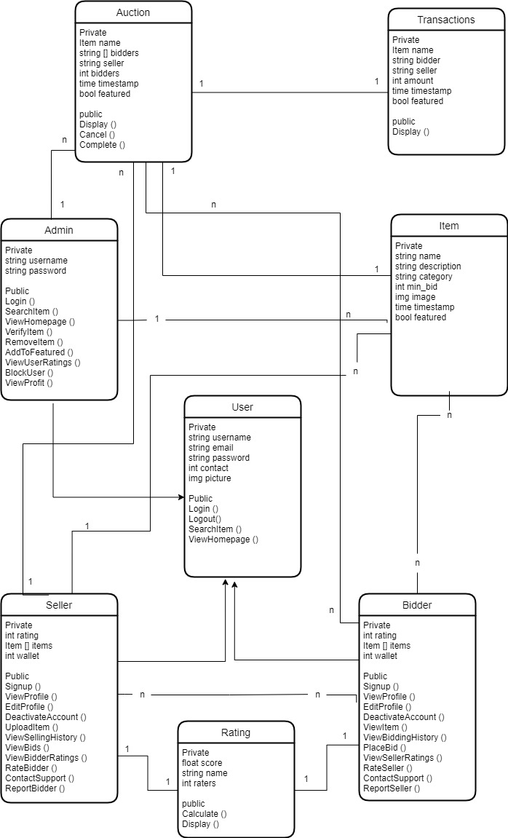

## Description

**Item**: Stores information regarding the item uploaded by the seller and also defines its status.

**User**: Contains **seller** and **bidder** class and stores their information. The seller uploads products that he/she wants to sell whereas the bidder places bids. The item is then sold to the bidder with the highest bid. Admin controls and manages the web app and ensures smooth auction process and also handles user complaints and queries

**Rating:** This is the rating class to compute and display user ratings

**Transactions:** Each object of this class is a successful transaction following the completion of an auction for record-keeping purposes

**Auction:** Each instance of this class is an item put up for bidding by a seller. It also contains information about the number of bidders.

[Isn’t the Admin also a user? Shouldn’t it be inherited from the User class?]

# Sequence Diagrams

[The sequence diagrams must have classes from the Class diagram you created earlier in this document. These diagrams must show the interactions among the system classes. In all of the sequence diagrams that you have created, there is hardly any classes from your class model. Moreover, you also need to complete the class model.]

## Signup

Changed

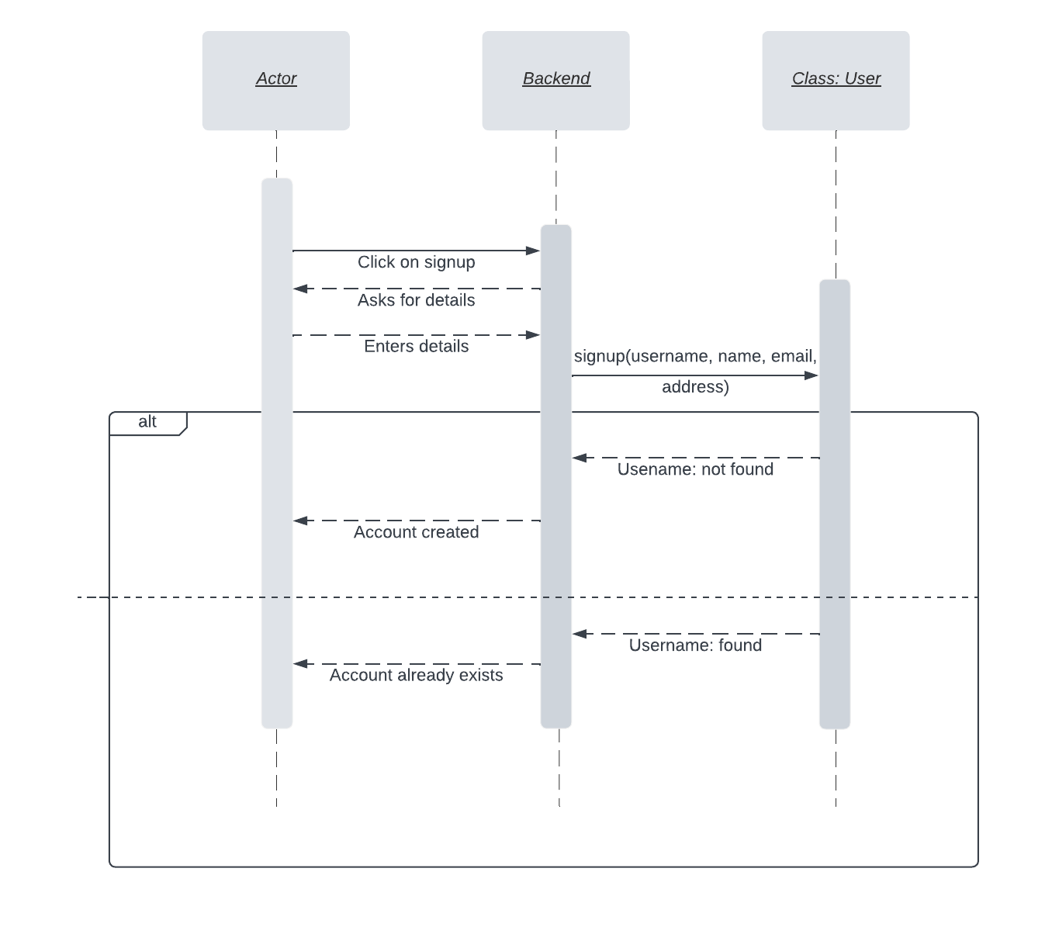

## Login

Changed

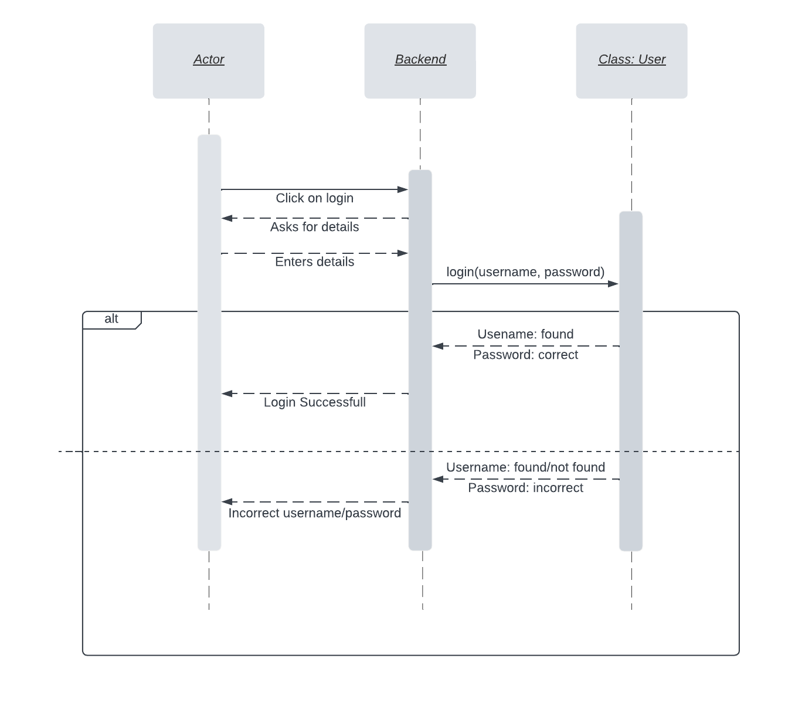

* 1. **View Home Page**

Changed

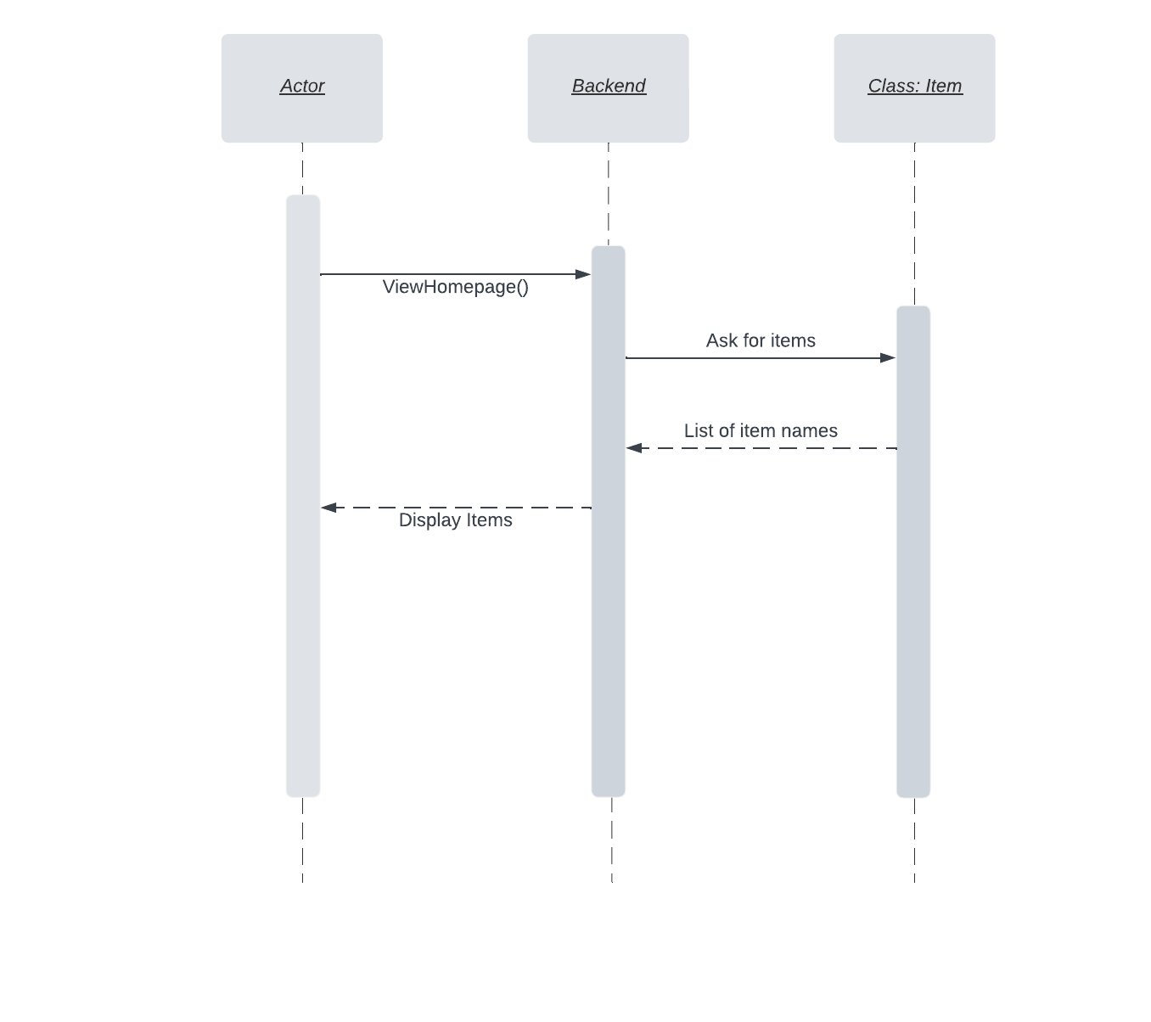

* 1. **View Product Description**

Changed

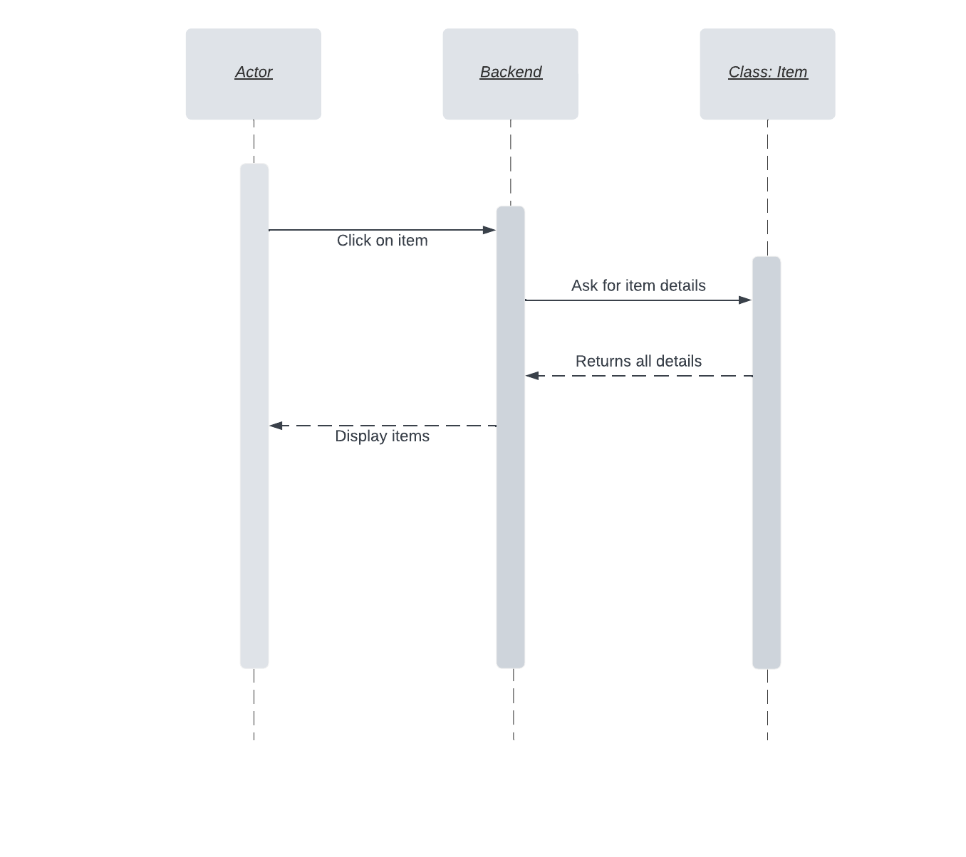

* 1. **Place Bids**

Changed

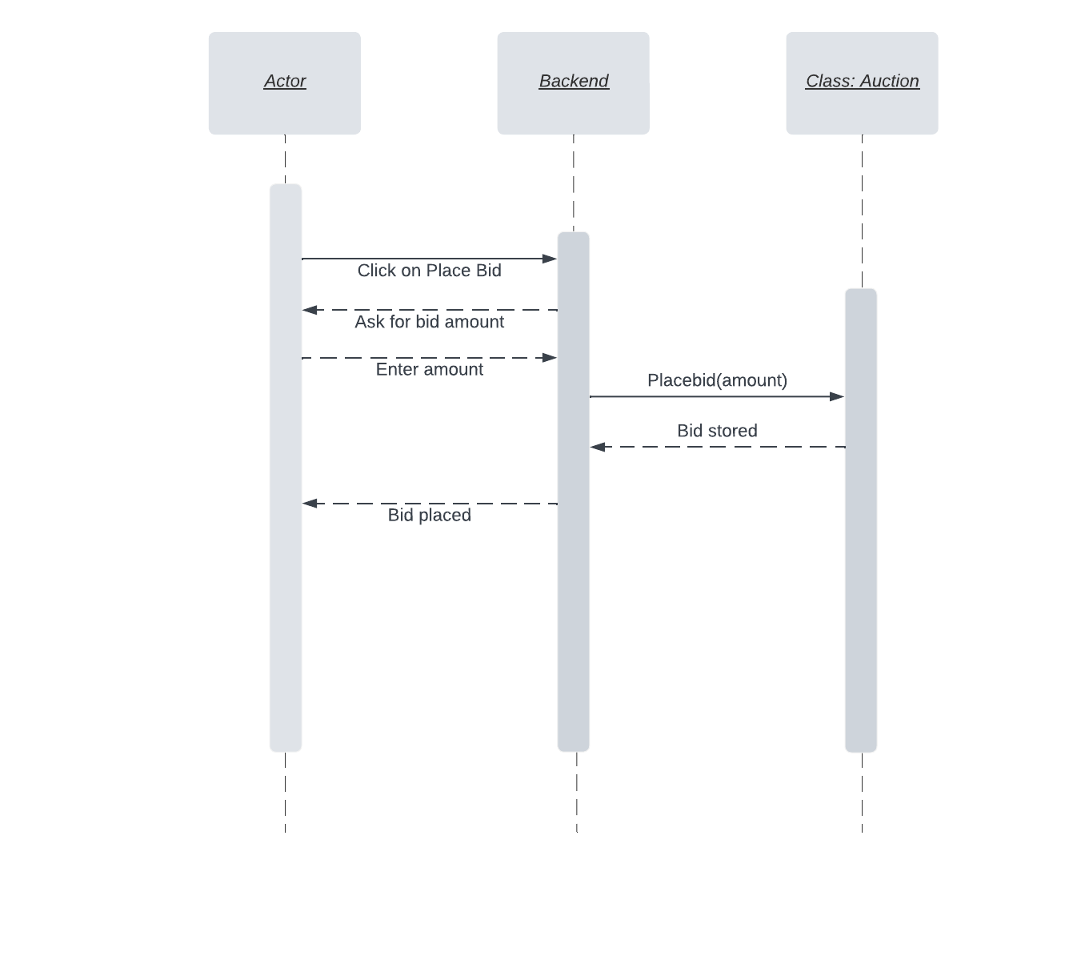

* 1. **View Bids**

Changed

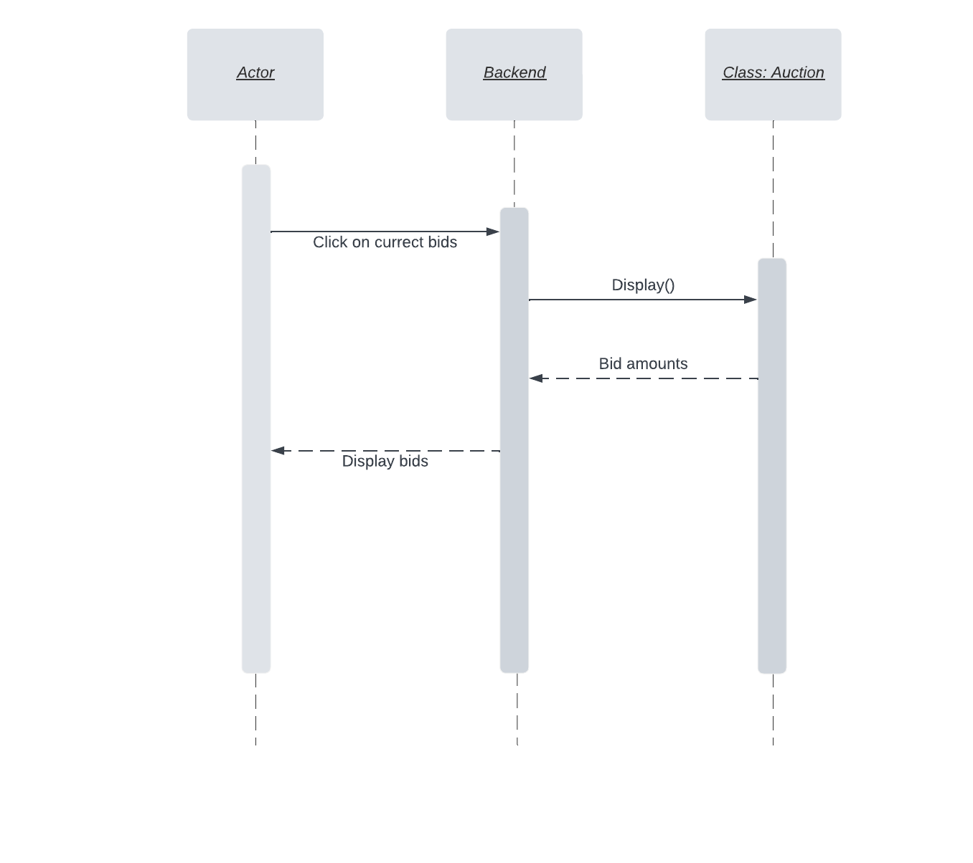

* 1. **Upload Item for Auction**

Changed

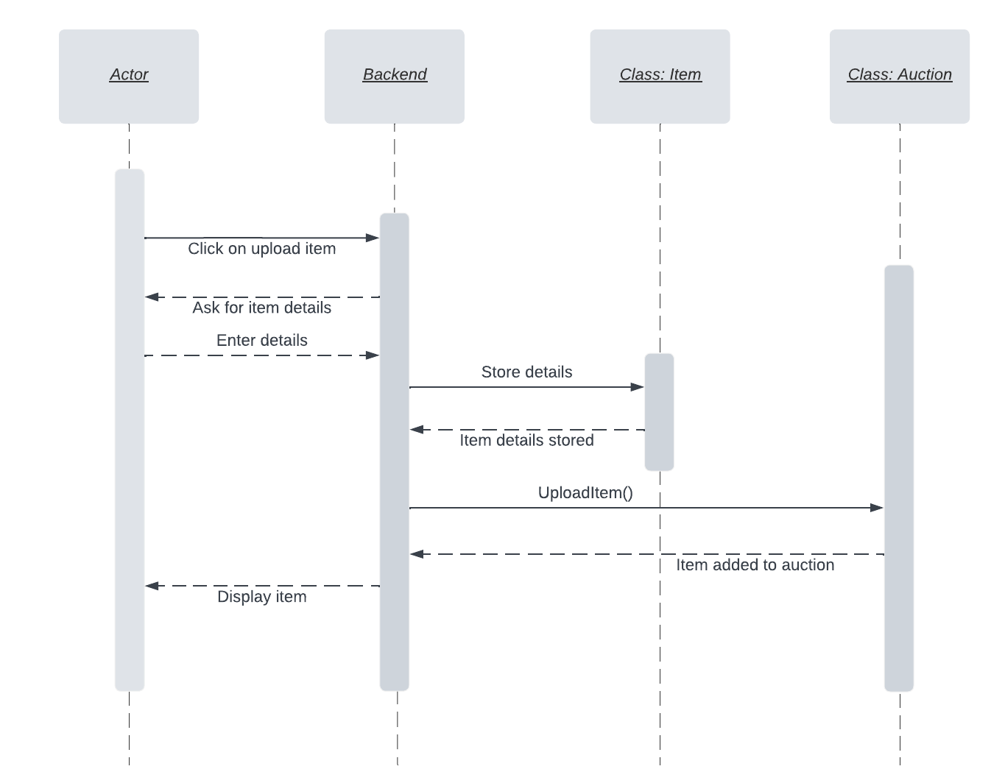

* 1. **Change Item Status**

Changed

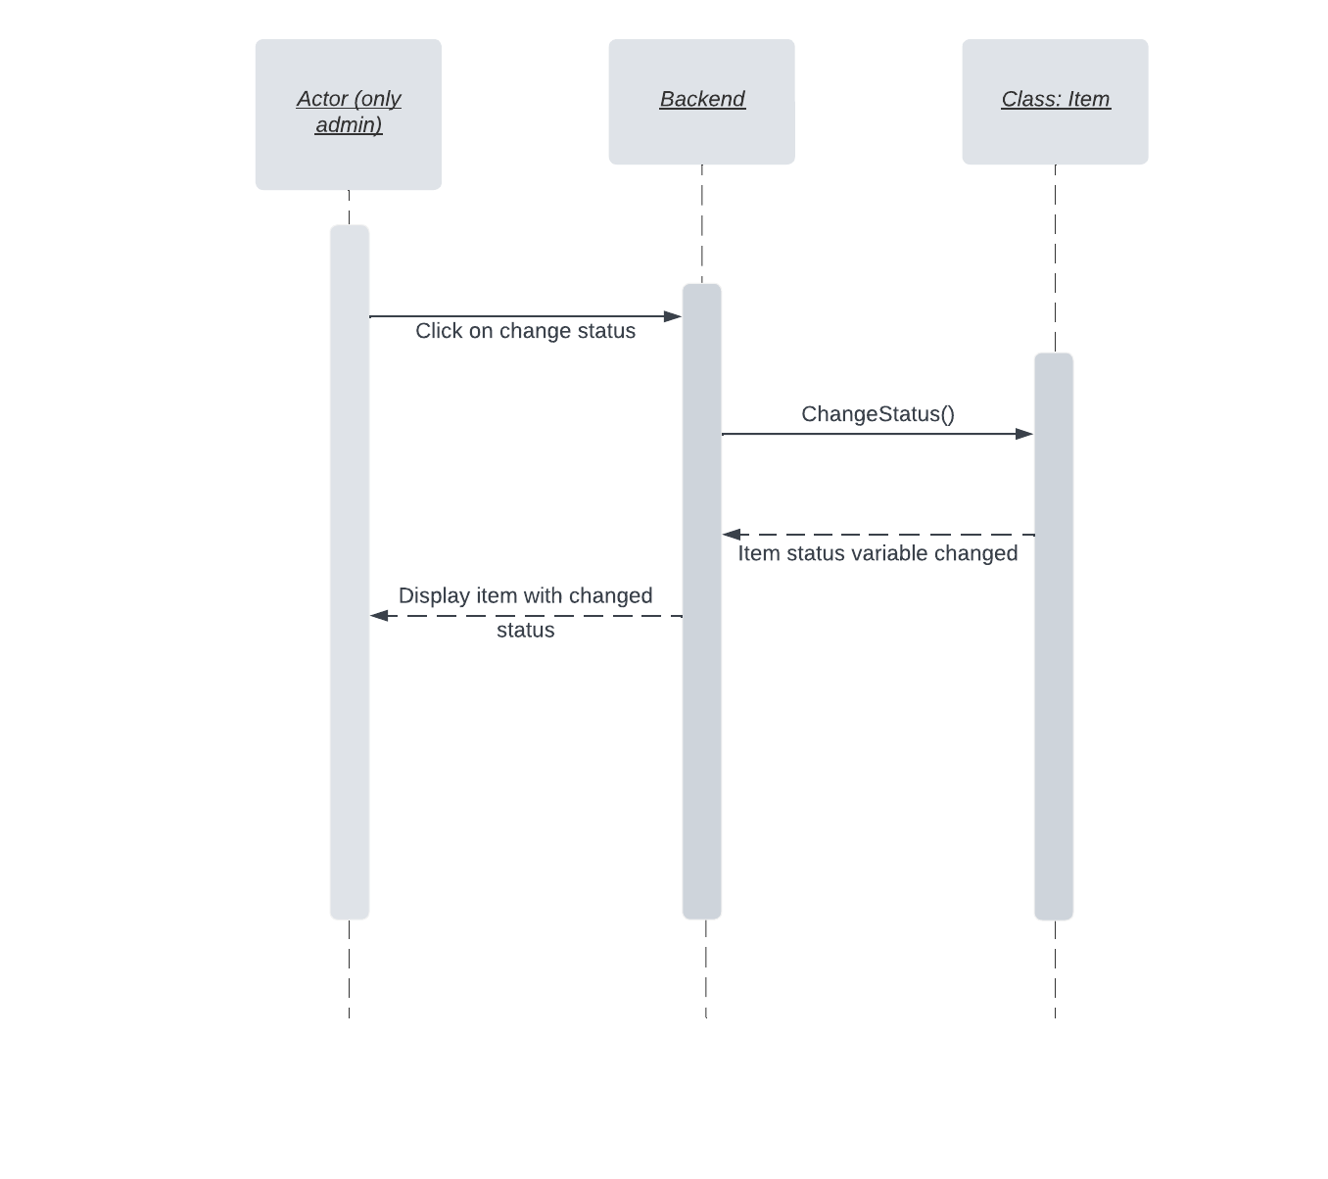

* 1. **Verify/Remove Item**

Changed

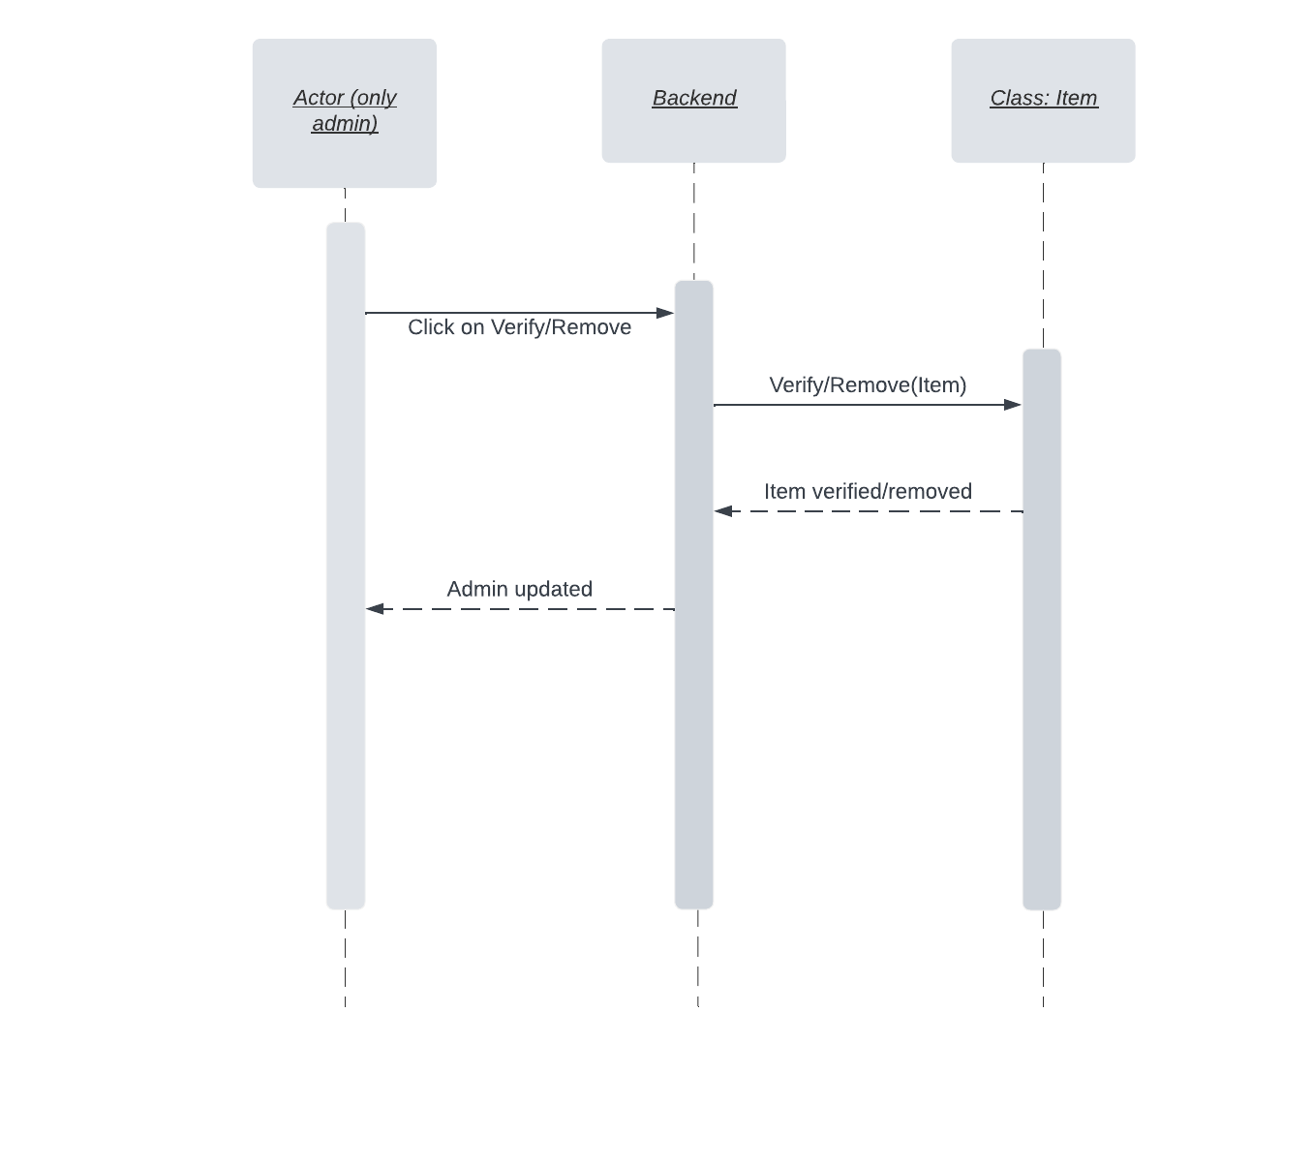

* 1. **View Profile**

Changed

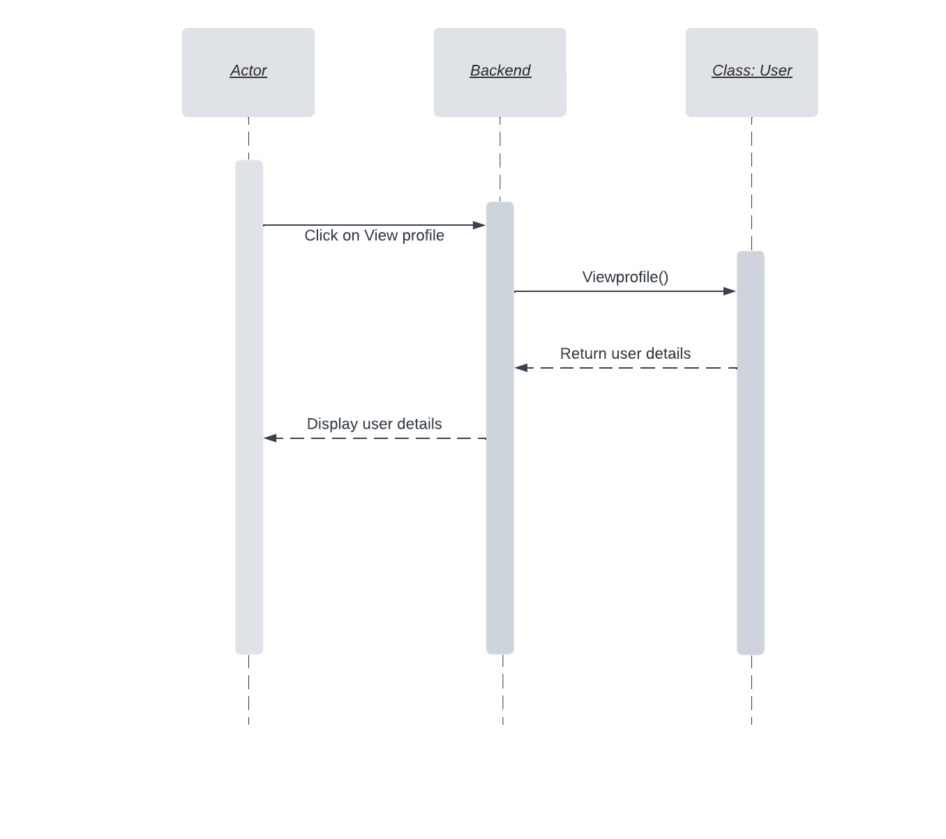

* 1. **Edit Profile**

Changed

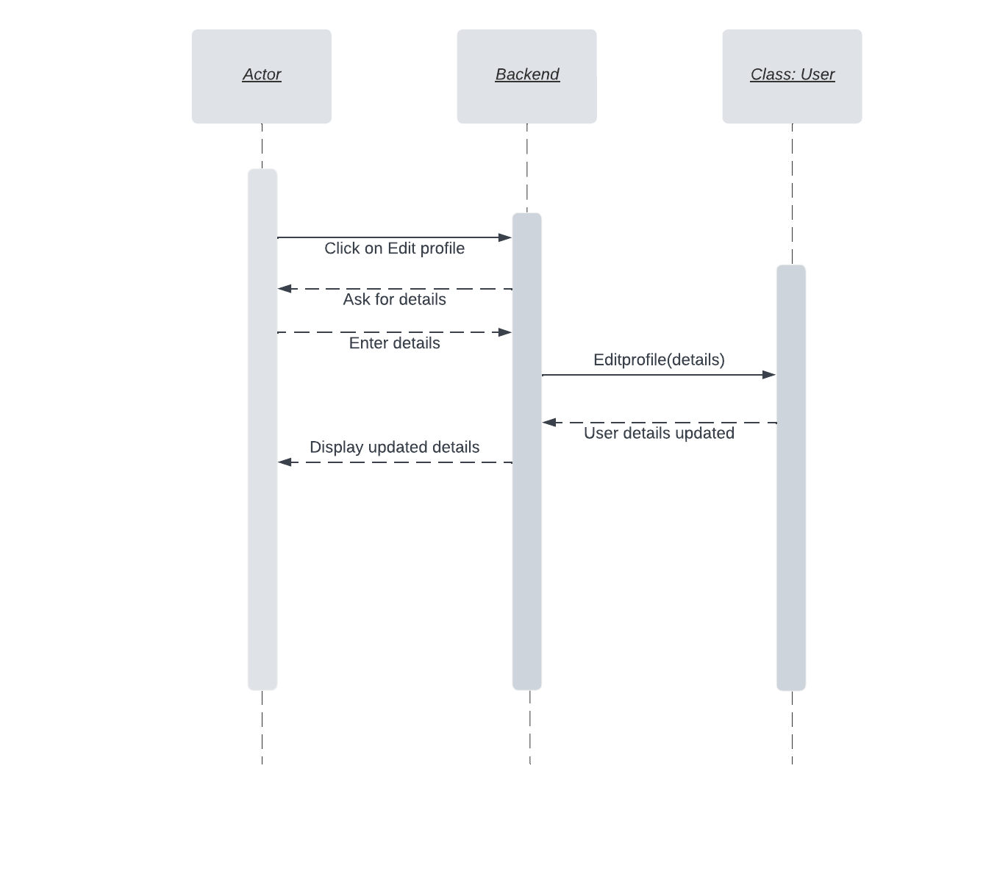

* 1. **Logout**

Changed

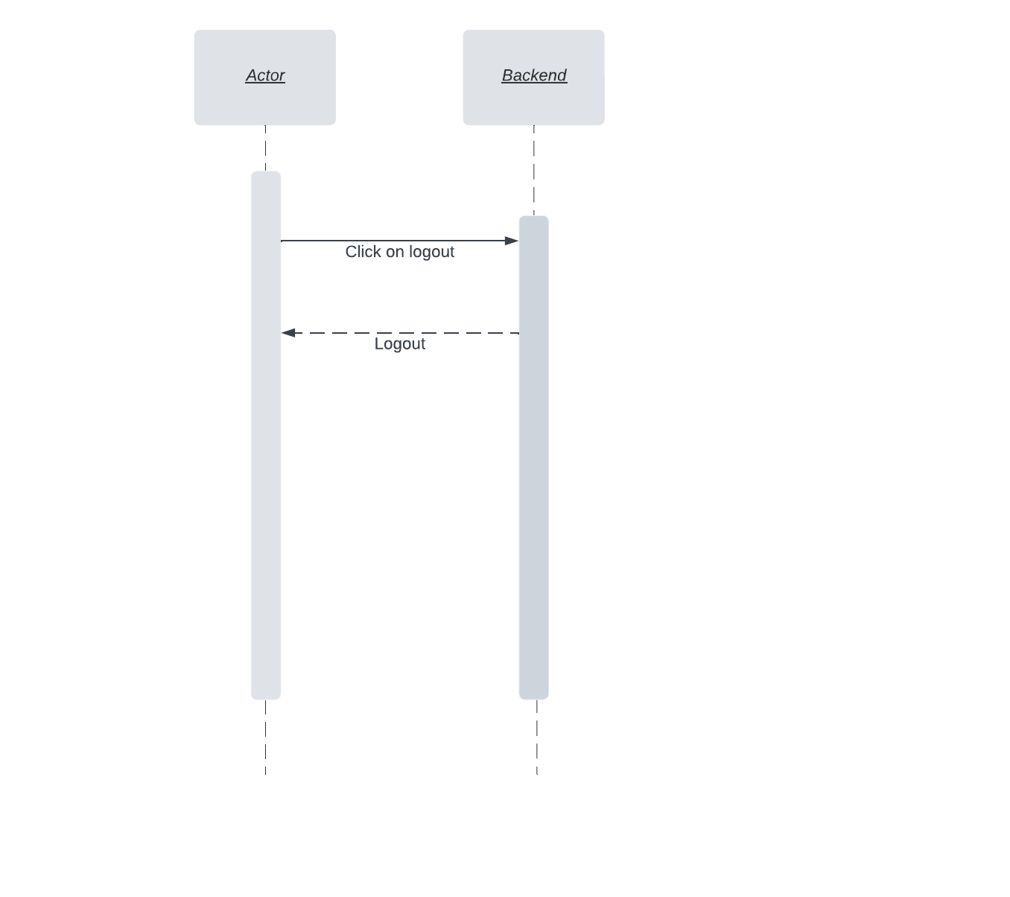

* 1. **Deactivate Account**

Changed

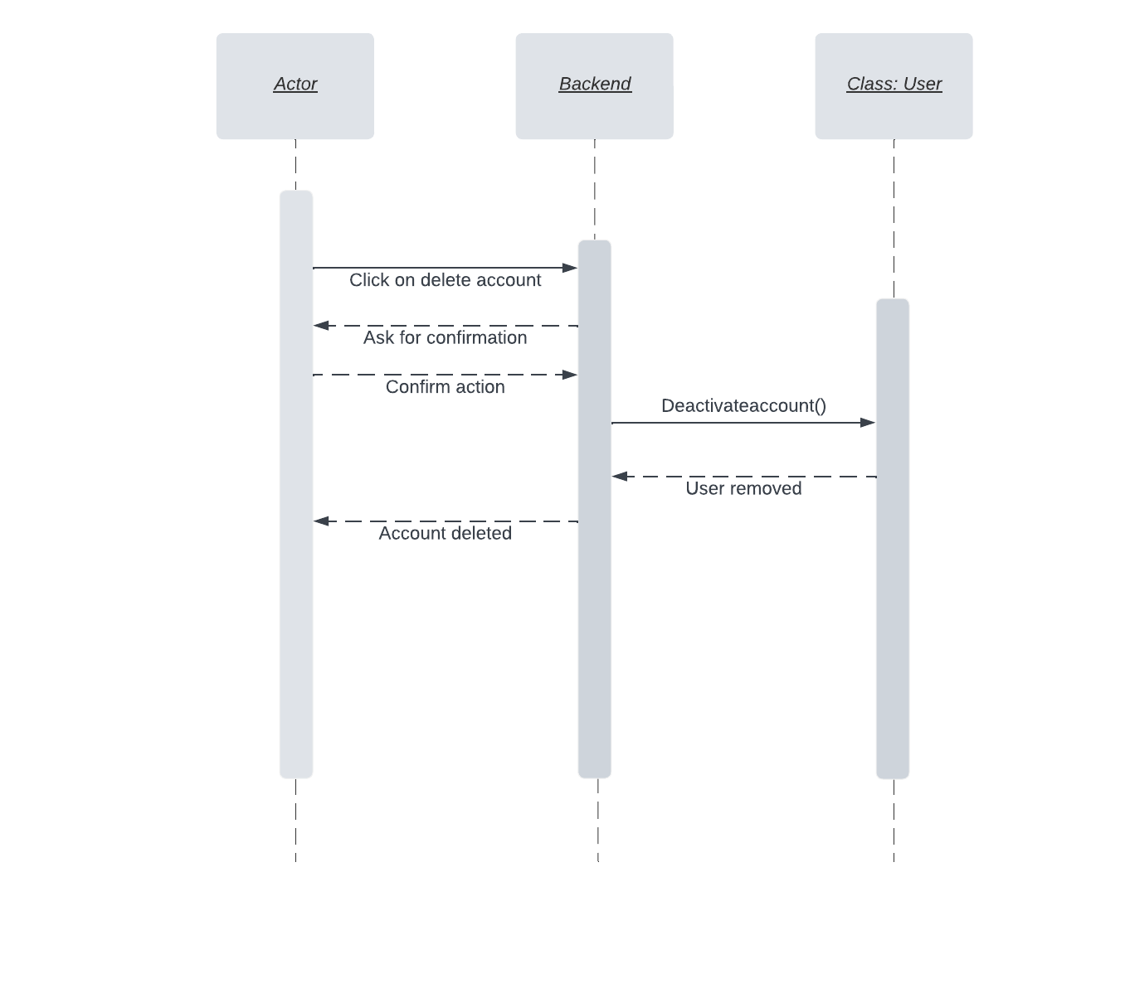

* 1. **Rate the seller/bidder**

Changed

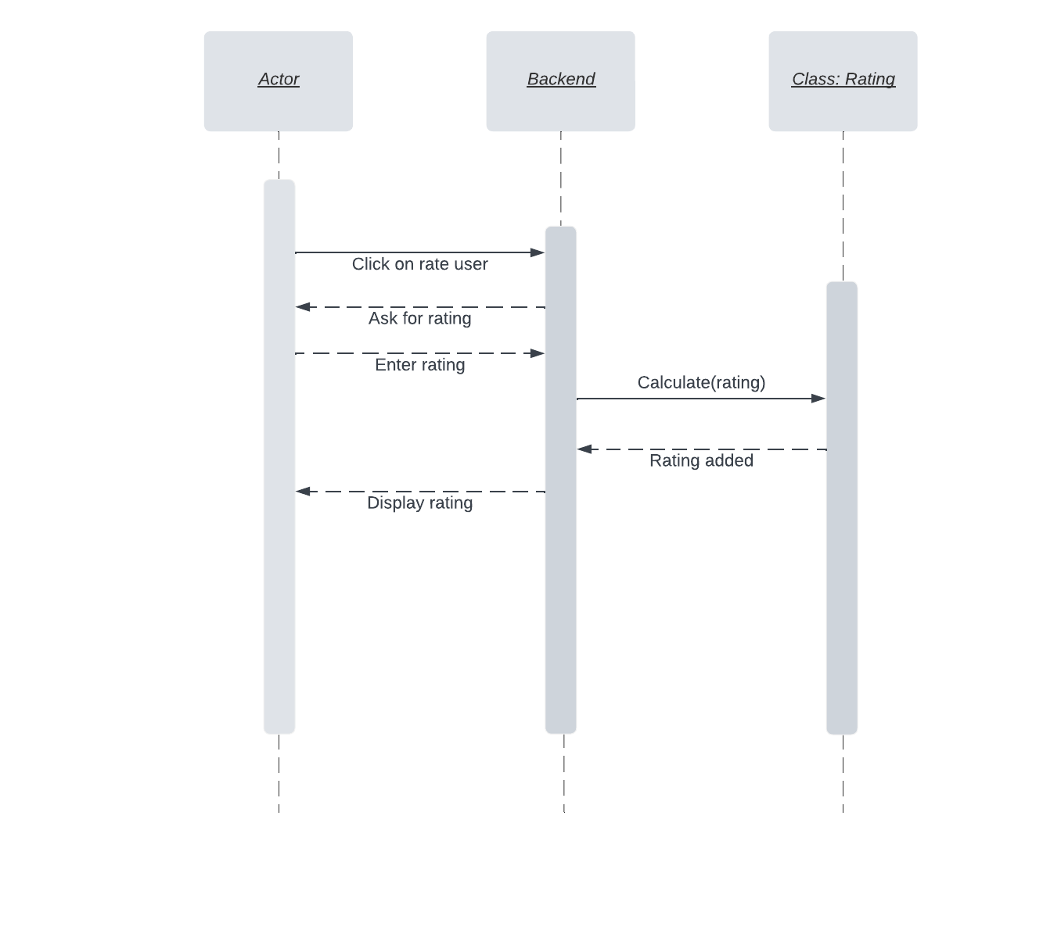

* 1. **Contact Customer Support**

Changed

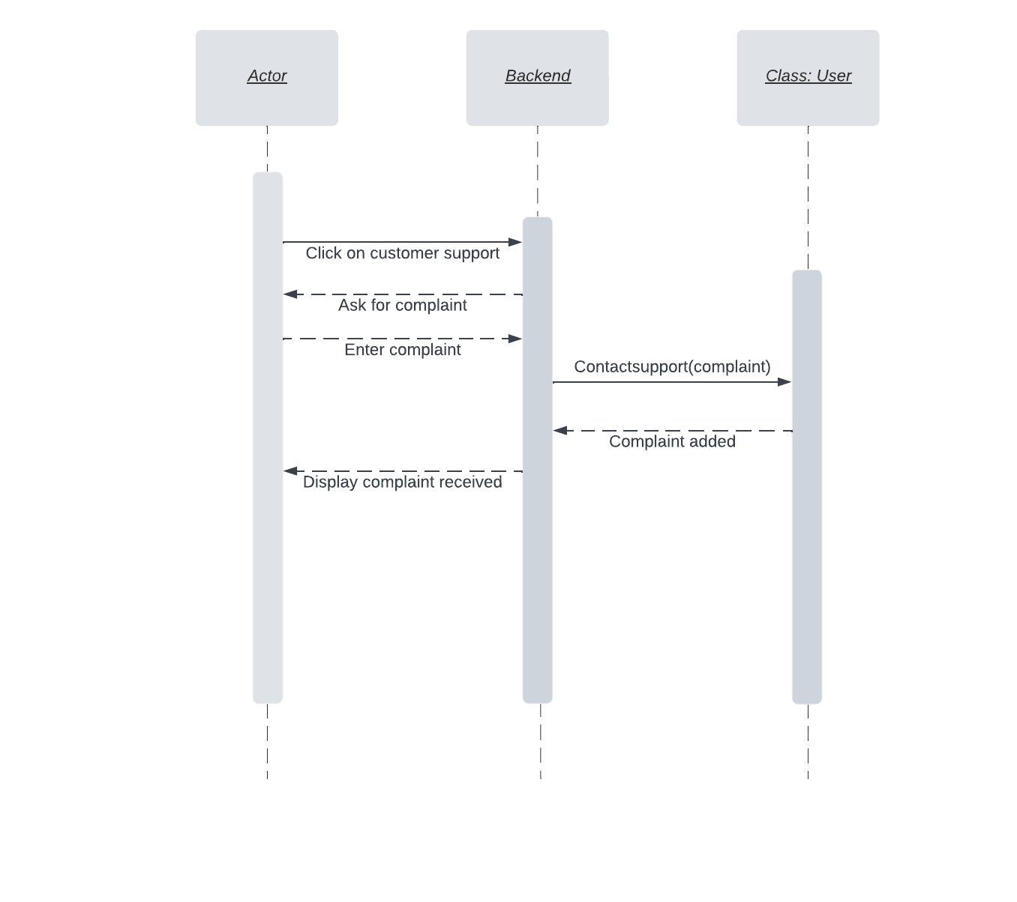

* 1. **View Featured Items**

Changed

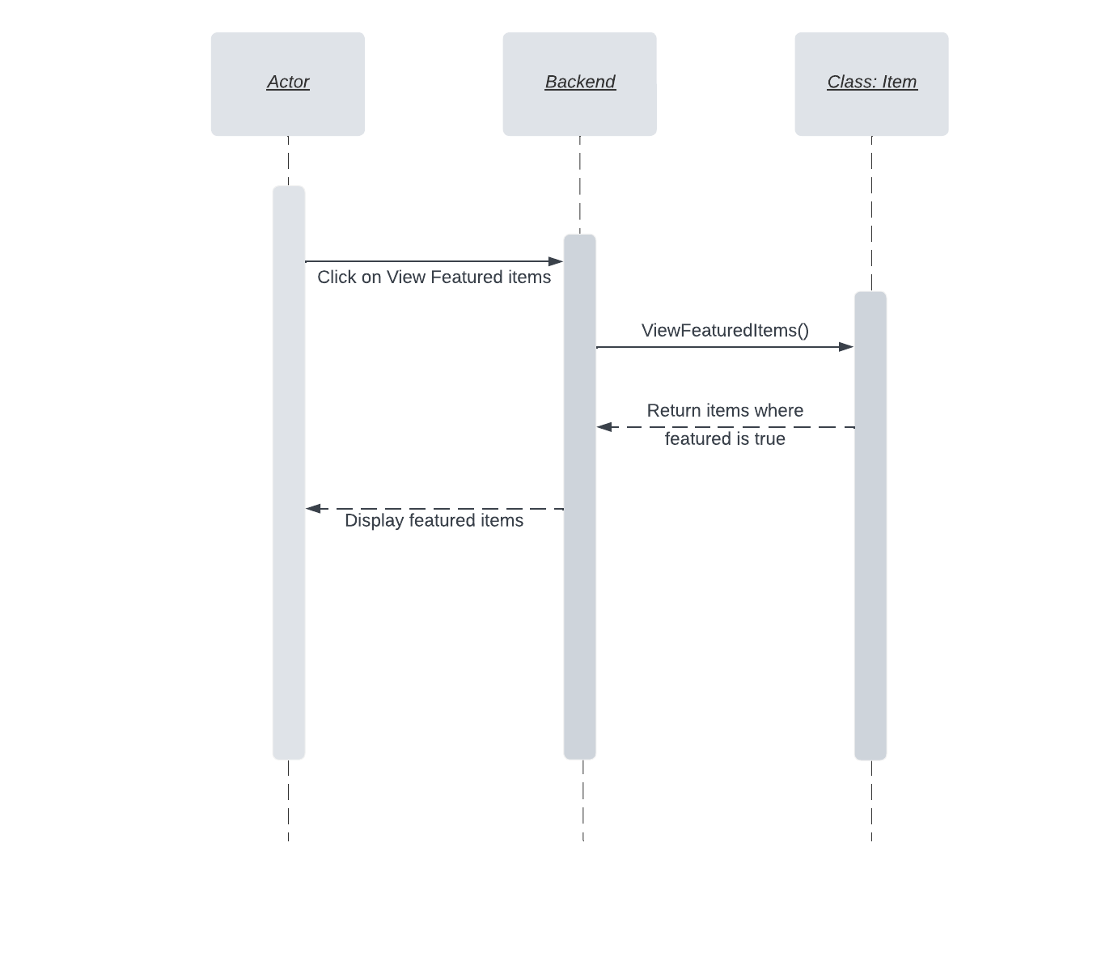

* 1. **View Bidding History**

Changed

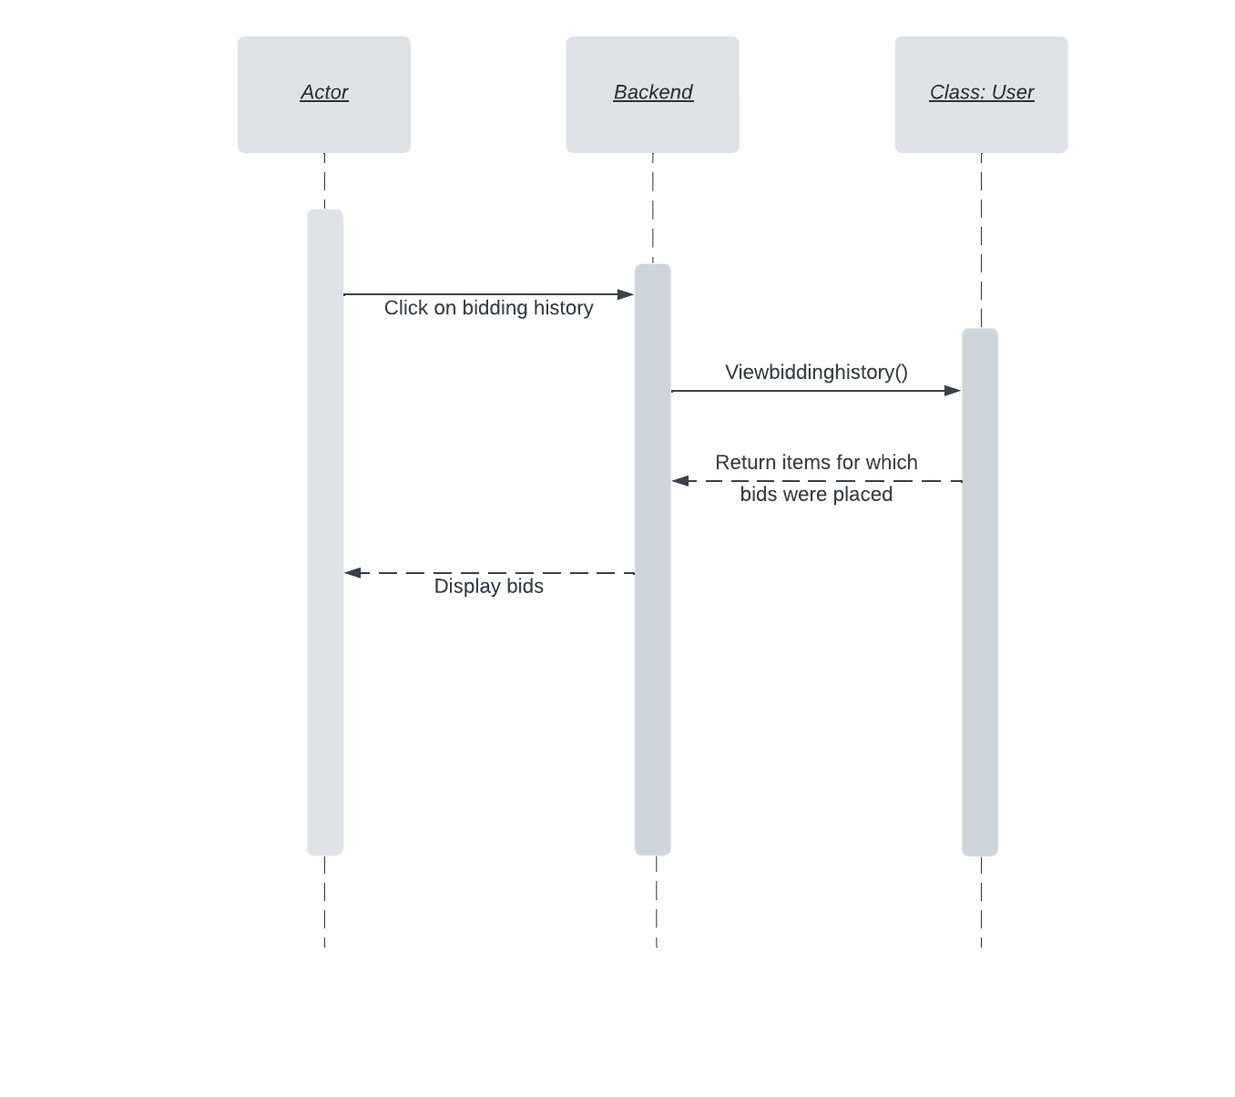

* 1. **View Selling History**

Changed

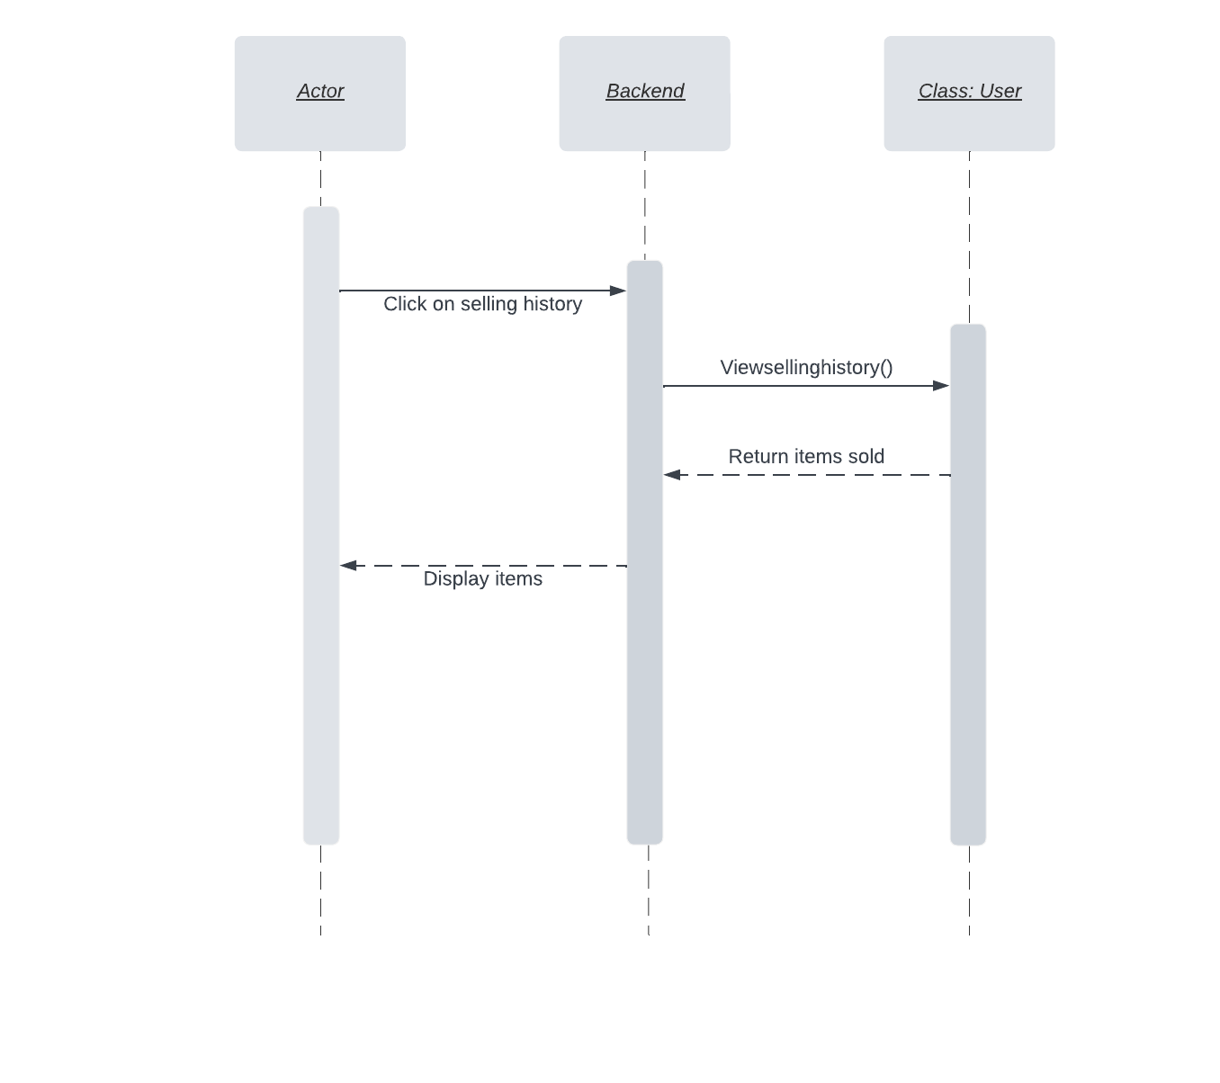

* 1. **Search Item**

Changed

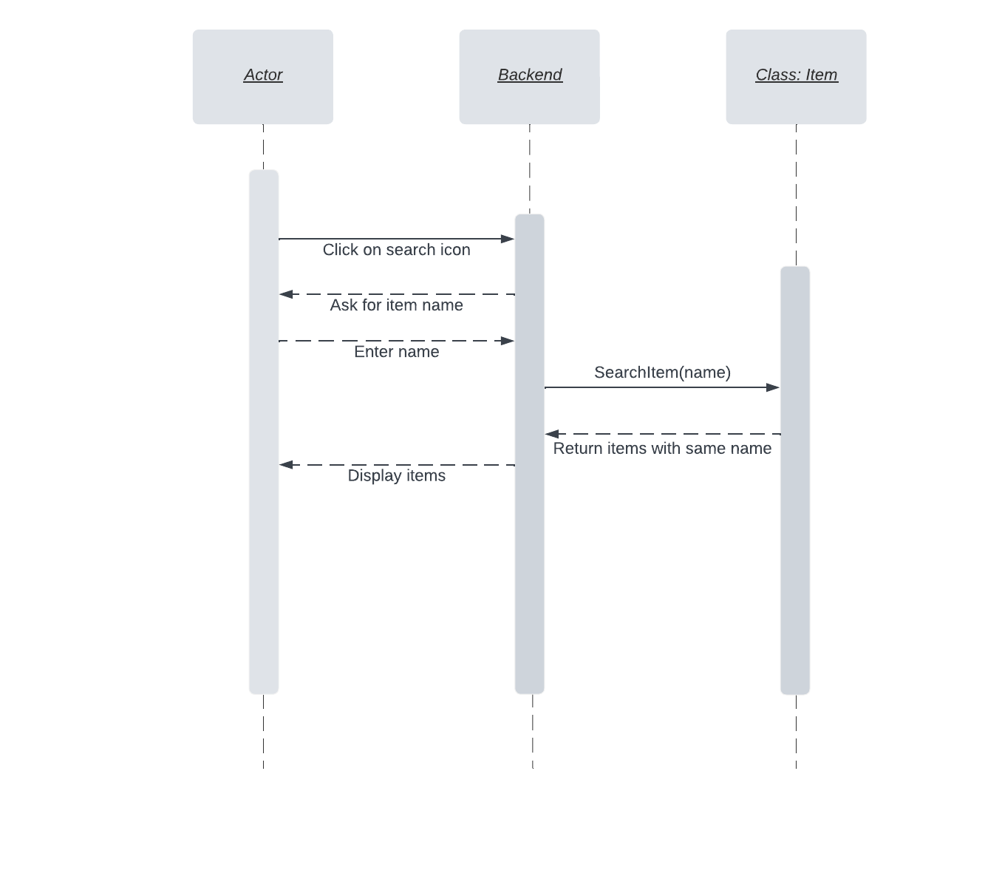

* 1. **Add Item to Featured Items**

Changed

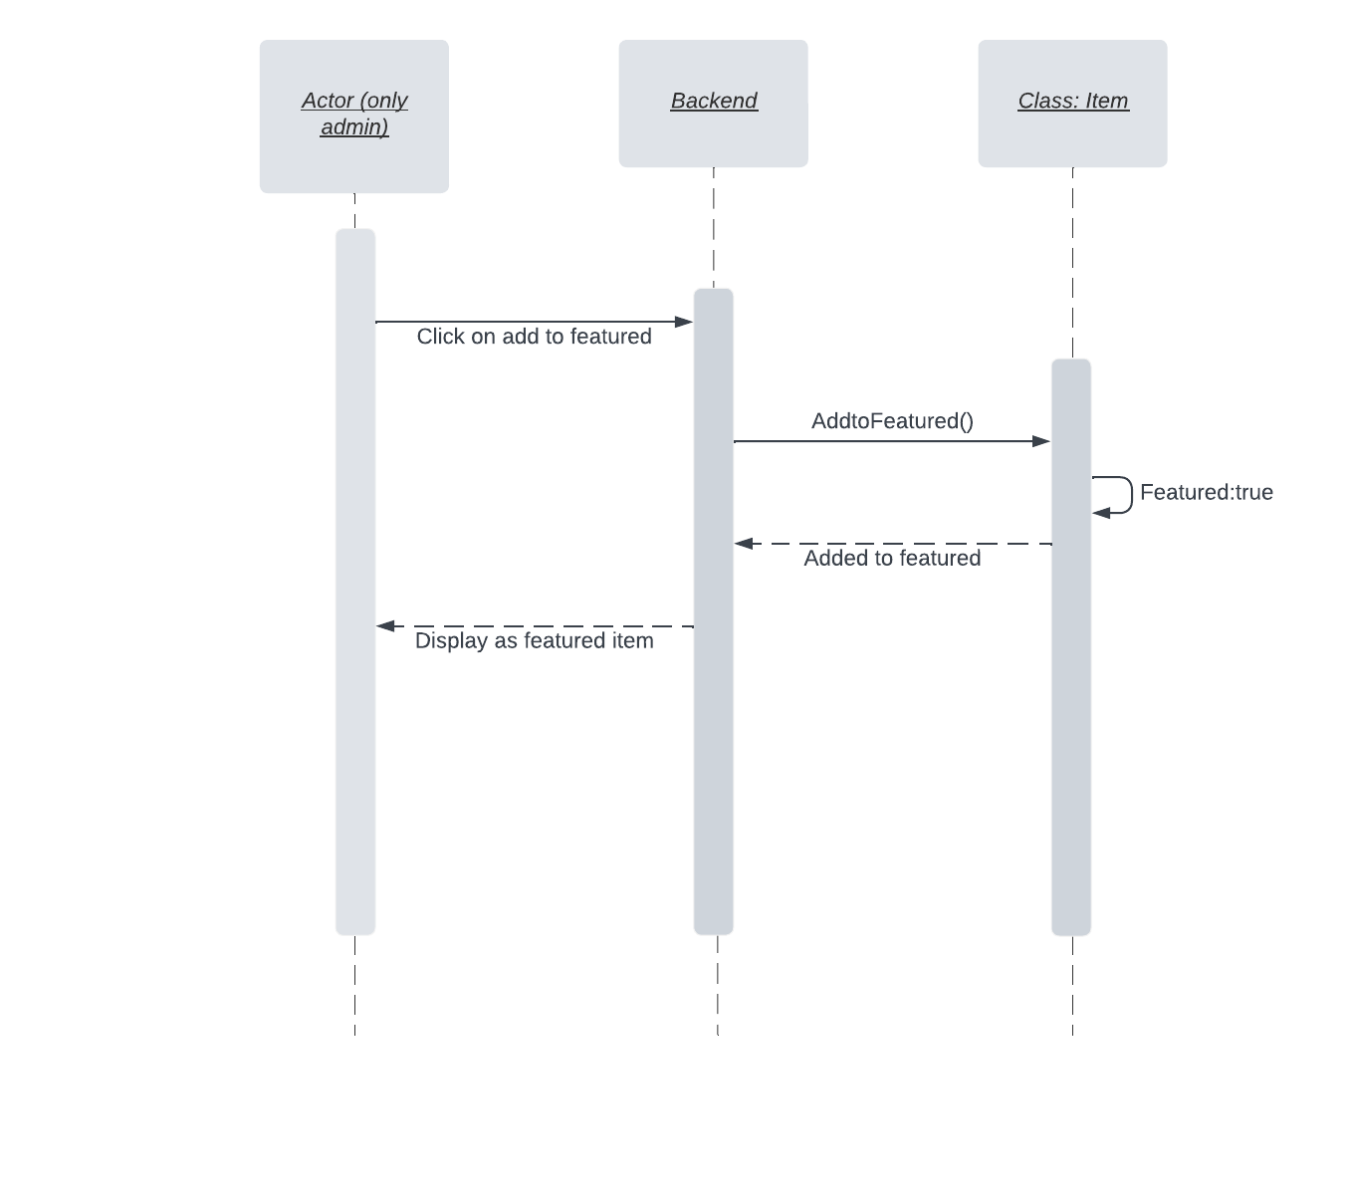

# State Diagrams

## Diagram details

The following diagram explains the state transitions that take place from the point a user signs in and walks through the process of auctioning an item. Once the timer expires, the item is sold to the highest bidder. In case there is no valid bid the seller is requested to either remove the product or auction the item again with a lower minimum bid amount.

## Diagram

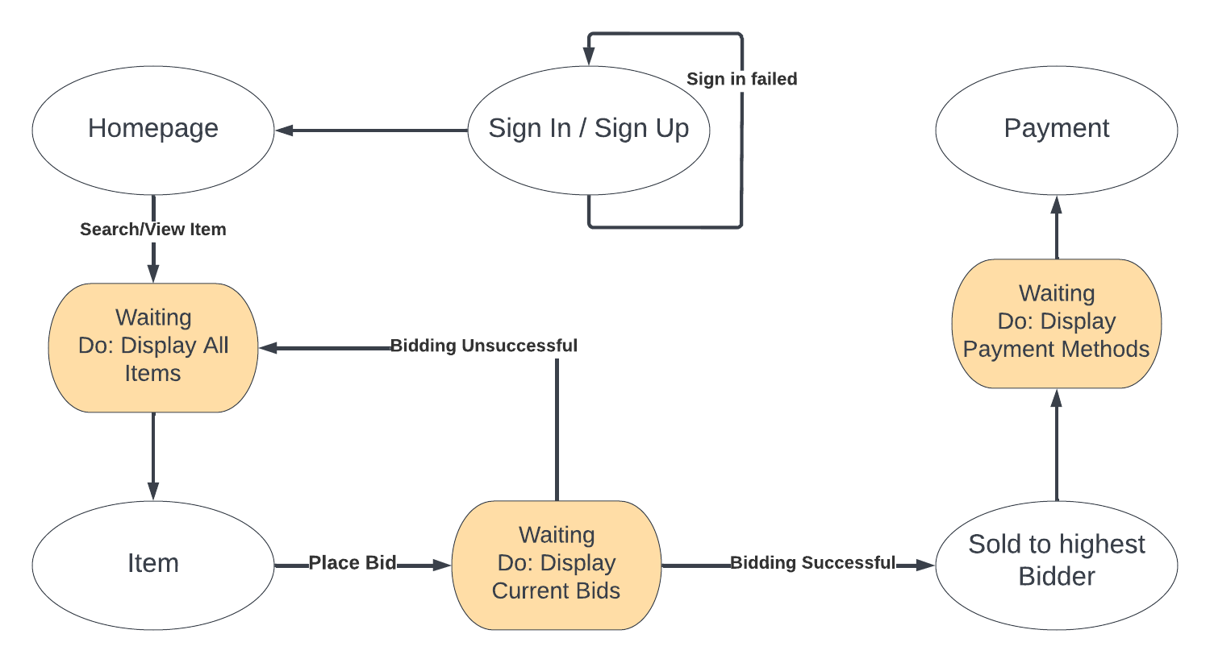

…..

# Non-functional Requirements / Quality Attributes

|  |  |
| --- | --- |
| **Sr#** | **Requirements** |
| 1 | The system should not utilize more than 1 GB of memory at any time during its execution. |
| 2 | The system should not fail more than three times every 24 hours. In case of a failure, the system should restore to normal operations within 5 minutes of failure. |
| 3 | The system should be secured using SSL and should support payment gateways. All passwords need to be encrypted using Bycrypt and stored in a database. |
| 4 | The webpages should have a minimum delay and load within 2-3 seconds. |
| 5 | After completion of auction process, the user should be notified with a appropriate message within 5 seconds. Customers should be informed of the latest status of their bid, such as "Your bid has been placed,” “Your item is up for auction,” etc. via a popup message |
| 6 | The website will conduct checks to ensure that all data entered into the system is correct. This information includes user phone numbers, email addresses, and a backup phone number if they have one. Furthermore, if an item is already auctioned, the system will ensure that no further bids are placed on it. |
| 7 | MongoDB database should not timeout and should be updated within 2-3 seconds. |
| 8 | Website should behave in accordance with user actions without any glitches or delays longer than 10 seconds. |
| 9 | Website should be consistent across all web pages such as in context of synchronization of bids. Bids shall not get removed upon switching web pages. |
| 10 | The website should have a simple layout to make it easy for the user to navigate without training. This will be accomplished by including toolbars, a home page, navigation bar and other widgets that will optimize user experience. |
| 11 | The back-end and front-end of the website shall be synchronized at all times and provide the users with real-time information. |
| 12 | The website shall be SEO compliant to catch traffic online. |
| 13 | The server will be up and running 24/7, allowing customers to access all website functions within 3 seconds of submitting a request. |
| 14 | Any device with a web browser and a reliable internet connection should be able to operate the system regardless of the operating system i.e windows, Linux, Mac OS. |
| 15 | We’ll check the website to make sure that it is up and running correctly on commonly used web browsers such as chrome and Microsoft Edge. |
| 16 | Weekly backups of the entire website, including the databases, will be made so that if the site collapses, we'll have a backup. |
| 17 | Selenium will be used to test the website because the majority of our use cases are highly testable, we will use component testing before launching. Our Selenium script will automatically test all functionalities with acceptable and unacceptable cases. Moreover, we will conduct our own separate tests to get user input. |
| 18 | The website should be able to easily modify the items to whatever the admin wishes them to be as admin shall have complete authority |
| 19 | The website shall be highly responsive in regard to different screen sizes. 15.6/14 inch laptop screen(1920x1080), 12.9 inch tablet screen(768x1024) and 6 inch mobile screen(360x800). |
| 20 | Maintenance of the system should be cost-effective, and any faults that appear should be easily repairable in 1 day at most and not cost more than 10000pkr. |

# Who Did What?

|  |  |
| --- | --- |
| **Name of the Team Member** | **Tasks done** |
| Nashit Iftikhar | Section 3: Use Cases |
| Mahad Mubashir Beg | Section 7: Non-Functional Requirements, Section 4: Class Diagram |
| Arsalan Tarar | Section 5: Sequence Diagrams, Section 3.1: Use Case Diagram |
| Silal Anwar Chatha | Section 1: Introduction, Section 3: Use Cases |
| Moiz Nafey | Section 6: State Diagram |

# Review checklist

Before submission of this deliverable, the team must perform an internal review. Each team member will review one or more sections of the deliverable.

|  |  |
| --- | --- |
| **Section** **Title** | **Reviewer Name(s)** |
| Non-Functional Requirements | Nashit Iftikhar |
| Sequence Diagrams | Mahad Mubashir Beg |
| State Diagram, Class Diagram | Silal Anwar |
| Use Cases | Arsalan Tarar |
| Use Case Diagram | Moiz Nafey |